UNITED STATES
SECURITIES AND EXCHANGE COMMISSION
Washington, D.C. 20549

Form 6-K

Report of Foreign Private Issuer
Pursuant to Rule 13a-16 or 15d-16 under the Securities Exchange Act of 1934

For the month of September and October 2026

Commission File Number 001-43454

Chilwa Minerals Ltd
(Exact name of Registrant as specified in its charter)

Not Applicable
(Translation of Registrant’s name into English)

Australia
(Jurisdiction of incorporation or organization)

Cadell Buss
Chief Executive Officer and Managing Director
Level 28, 140 St Georges Terrace
Perth, WA 6005
Australia
(Address of principal executive offices)

Indicate by check mark whether the registrant files or will file annual reports under cover Form 20-F or Form 40-F:

Form 20-F ☒ Form 40-F ☐

INFORMATION CONTAINED ON THIS REPORT ON FORM 6-K

Attached to this report on Form 6-K is (i) Exhibit 99.1, a copy of the press release of Chilwa Minerals Limited dated September 30, 2026, titled “Chilwa Announces Nasdaq listing and Pricing of US$3.5 million Offering” and (ii) Exhibit 99.2, a copy of the press release of Chilwa Minerals Limited dated October 2, 2026, titled “Chilwa Announces Closing of US$3.5 million Offering”.

This report on Form 6-K (including any exhibit hereto) shall not be deemed to be “filed” for purposes of the Securities Exchange Act of 1934 and shall not be incorporated by reference into any registration statement or prospectus under the Securities Act of 1933 except as may be expressly set forth by specific reference in such registration statement or prospectus.

1

SIGNATURES

Pursuant to the requirements of the Securities Exchange Act of 1934, the registrant has duly caused this report to be signed on its behalf by the undersigned, thereunto duly organized.

Chilwa Minerals Limited
/s/ Susan Park
Susan Park
Company Secretary

Dated: October 2, 2026

2

INDEX TO EXHIBITS

Item
99.1 |  | Press Release dated September 30, 2026
99.2 |  | Press Release dated October 2, 2026

3

Exhibit 99.1

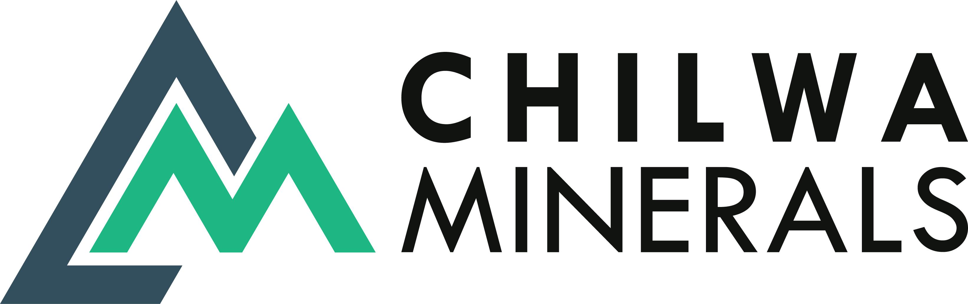
September 30, 2026

Chilwa ANNOUNCES NASDAQ LISTING AND PRICING OF US$3.5 MILLION OFFERING

highlights

 | ● | Chilwa Minerals Limited has raised approximately US$3.5 million through an underwritten offering of American Depositary Shares (ADS)

 | ● | Chilwa’s ADS will be listed on the Nasdaq Capital Market (Nasdaq), while its ordinary shares continue to trade on the Australian Securities Exchange (ASX).

 | ● | Funds raised will be used to further Chilwa’s mineral exploration activities, for working capital and other general corporate purposes.

Overview

Chilwa Minerals Limited, an Australian company (ASX:CHW, NASDAQ:CHWM) (Chilwa or the Company), is pleased to announce the pricing of its underwritten public offering. The offering consists of 625,000 American Depositary Shares (“ADSs”) and warrants to purchase 625,000 ADSs at an offering price of $5.60 per ADS and accompanying warrant. Each ADS offered represents 10 ordinary shares of Chilwa. The gross proceeds, before deducting underwriter discounts and offering expenses, are expected to be US$3.5 million. The warrants will have an exercise price of US$5.60 per ADS, will be exercisable immediately upon issuance and will expire on the fifth anniversary of the original issuance date. The ADSs are expected to begin trading on the Nasdaq Capital Market under the ticker symbol “CHWM” on October 1, 2026.

In addition, Chilwa has granted the underwriter a 45-day option to purchase up to an additional 92,000 ADSs and/or additional 92,000 warrants to purchase up to 92,000 ADSs at the public offering price, less underwriting discounts, and commissions. The offering is expected to close on or about October 2, 2026 (New York time), subject to satisfaction of customary closing conditions.

Maxim Group LLC is acting as sole book-running manager and underwriter for the offering.

The Company intends to use the net proceeds from this offering to further its mineral exploration activities, for working capital and other general corporate purposes.

A registration statement on Form F-1 (File No. 333-297336) relating to the public offering was filed with the Securities and Exchange Commission (“SEC”) and became effective on September 29, 2026. The offering is being made only by means of a prospectus. Copies of the final prospectus, when available, may be obtained from Maxim Group LLC, 300 Park Ave, 16th Floor, New York, New York 10022. The final prospectus will be filed with the SEC and will be available on the SEC’s website located at http://www.sec.gov.

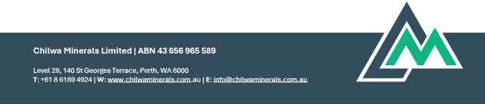

30 September 2026 | 
Chilwa ANNOUNCES NASDAQ LISTING AND PRICING OF
US$3.5 MILLION OFFERING

This announcement shall not constitute an offer to sell or a solicitation of an offer to buy, nor shall there be any sale of these securities in any state or jurisdiction in which such an offer, solicitation or sale would be unlawful prior to registration or qualification under the securities laws of any such state or jurisdiction.

-ENDS-

For further information contact:

Cadell Buss

Founder and Managing Director

cbuss@chilwaminerals.com.au

About Chilwa Minerals Limited

Chilwa is an Australian mineral exploration company that was formed for the purpose of acquiring the Chilwa Critical Minerals Project (Project) from Luso Global Mining BV. Upon listing on the ASX in July 2023, Chilwa acquired 100% of the issued share capital of Chilwa Minerals Africa Limited, an entity incorporated in Malawi that holds the tenements that comprise the Project. Chilwa’s principal activities are mineral exploration at the Project.

Cautionary Note Regarding Forward-Looking Statements

This announcement contains forward-looking statements about Chilwa and its industry that involve substantial risks and uncertainties. All statements other than statements of historical facts contained in this announcement, including statements regarding our future results of operations, financial condition, business strategy and plans and objectives of management for future operations, are forward-looking statements. In some cases, you can identify forward-looking statements because they contain words such as “anticipate,” “believe,” “contemplate,” “continue,” “could,” “estimate,” “expect,” “intend,” “may,” “plan,” “potential,” “predict,” “project,” “should,” “target,” “will,” or “would,” or the negative of these words or other similar terms or expressions.

www.chilwaminerals.com.au | Page 2 of 3

30 September 2026

Chilwa ANNOUNCES NASDAQ LISTING AND PRICING OF
US$3.5 MILLION OFFERING

The Company has based these forward-looking statements largely on its current expectations and projections about future events and trends that we believe may affect Chilwa’s financial condition, results of operations, business strategy and financial needs. These forward-looking statements are subject to a number of known and unknown risks, uncertainties, other factors and assumptions, including, among other things: our exploration activities and our business operations in general; sufficiency of our cash resources; our ability to profitably extract minerals; our ability to raise additional funding when needed; any statements concerning anticipated regulatory approvals or collaborative arrangements, including our ability to obtain governmental approvals and permits; our operational risks; our ability to remain compliant with the Australian Securities Exchange and Nasdaq’s continuing listing standards; our ability to remediate identified material weaknesses in our internal control over financial reporting; any statement of assumptions underlying any of the foregoing; and other risks and uncertainties, including those listed under “Risk Factors” in the US registration statement file on Form F-1. These risks are not exhaustive. New risk factors may emerge from time to time and it is not possible for our management to predict all risk factors, nor can we assess the impact of all factors on our business or the extent to which any factor, or combination of factors, may cause actual results to differ materially from those contained in, or implied by, any forward-looking statements.

Although the Company has attempted to identify important factors that cause results not to be as anticipated, estimated or intended, there can be no assurance that such forward-looking information will prove to be accurate, as actual results and future events could differ materially from those anticipated in such information. Accordingly, readers should not place undue reliance on forward looking information. Forward looking information is made as of the date of this announcement and the Company does not undertake to update or revise any forward-looking information which is included herein, except in accordance with applicable securities laws.

www.chilwaminerals.com.au | Page 3 of 3

Exhibit 99.2

 | October 2, 2026

Chilwa ANNOUNCES CLosing OF US$3.5 MILLION OFFERING

Overview

Chilwa Minerals Limited, an Australian company (ASX:CHW, NASDAQ:CHWM) (Chilwa or the Company), is pleased to announce the closing of its underwritten public offering. The offering consisted of 625,000 American Depositary Shares (“ADSs”) and warrants to purchase 625,000 ADSs at an offering price of US$5.60 per ADS and accompanying warrant. Each ADS offered represents 10 ordinary shares of Chilwa. The gross proceeds, before deducting underwriter discounts and offering expenses, were US$3.5 million. The warrants have an exercise price of US$5.60 per ADS, are exercisable immediately upon issuance and expire on the fifth anniversary of the original issuance date. The ADSs began trading on the Nasdaq Capital Market under the ticker symbol “CHWM” on October 1, 2026.

In addition, Chilwa granted the underwriter a 45-day option to purchase up to an additional 92,000 ADSs and/or additional 92,000 warrants to purchase up to 92,000 ADSs at the public offering price, which was partially exercised to purchase 92,000 warrants.

Maxim Group LLC acted as sole book-running manager and underwriter for the offering. The Company’s ADS program is administered by BNY.

The Company intends to use the net proceeds from this offering to further its mineral exploration activities, for working capital and other general corporate purposes.

A registration statement on Form F-1 (File No. 333-297336) relating to the public offering was filed with the Securities and Exchange Commission (“SEC”) and became effective on September 29, 2026. The offering was made only by means of a prospectus. Copies of the final prospectus may be obtained from Maxim Group LLC, 300 Park Ave, 16th Floor, New York, New York 10022. The final prospectus has been filed with the SEC and is available on the SEC’s website located at http://www.sec.gov.

This announcement shall not constitute an offer to sell or a solicitation of an offer to buy, nor shall there be any sale of these securities in any state or jurisdiction in which such an offer, solicitation or sale would be unlawful prior to registration or qualification under the securities laws of any such state or jurisdiction.

-ENDS-

For further information contact:

Cadell Buss

Founder and Managing Director

cbuss@chilwaminerals.com.au

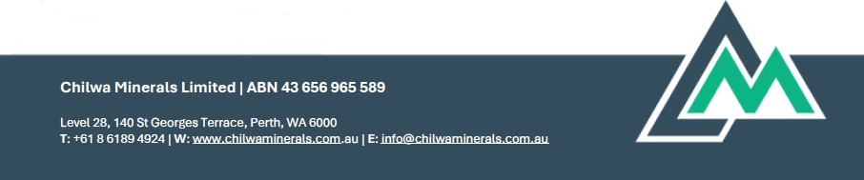

October 2, 2026  CHILWA ANNOUNCES CLOSING OF US$3.5 MILLION OFFERING | 

About Chilwa Minerals Limited

Chilwa is an Australian mineral exploration company that was formed for the purpose of acquiring the Chilwa Critical Minerals Project (Project) from Luso Global Mining BV. Upon listing on the ASX in July 2023, Chilwa acquired 100% of the issued share capital of Chilwa Minerals Africa Limited, an entity incorporated in Malawi that holds the tenements that comprise the Project. Chilwa’s principal activities are mineral exploration at the Project.

Cautionary Note Regarding Forward-Looking Statements

This announcement contains forward-looking statements about Chilwa and its industry that involve substantial risks and uncertainties. All statements other than statements of historical facts contained in this announcement, including statements regarding our future results of operations, financial condition, business strategy and plans and objectives of management for future operations, are forward-looking statements. In some cases, you can identify forward-looking statements because they contain words such as “anticipate,” “believe,” “contemplate,” “continue,” “could,” “estimate,” “expect,” “intend,” “may,” “plan,” “potential,” “predict,” “project,” “should,” “target,” “will,” or “would,” or the negative of these words or other similar terms or expressions.

The Company has based these forward-looking statements largely on its current expectations and projections about future events and trends that we believe may affect Chilwa’s financial condition, results of operations, business strategy and financial needs. These forward-looking statements are subject to a number of known and unknown risks, uncertainties, other factors and assumptions, including, among other things: our exploration activities and our business operations in general; sufficiency of our cash resources; our ability to profitably extract minerals; our ability to raise additional funding when needed; any statements concerning anticipated regulatory approvals or collaborative arrangements, including our ability to obtain governmental approvals and permits; our operational risks; our ability to remain compliant with the Australian Securities Exchange and Nasdaq’s continuing listing standards; our ability to remediate identified material weaknesses in our internal control over financial reporting; any statement of assumptions underlying any of the foregoing; and other risks and uncertainties, including those listed under “Risk Factors” in the US registration statement file on Form F-1. These risks are not exhaustive. New risk factors may emerge from time to time and it is not possible for our management to predict all risk factors, nor can we assess the impact of all factors on our business or the extent to which any factor, or combination of factors, may cause actual results to differ materially from those contained in, or implied by, any forward-looking statements.

Although the Company has attempted to identify important factors that cause results not to be as anticipated, estimated or intended, there can be no assurance that such forward-looking information will prove to be accurate, as actual results and future events could differ materially from those anticipated in such information. Accordingly, readers should not place undue reliance on forward looking information. Forward looking information is made as of the date of this announcement and the Company does not undertake to update or revise any forward-looking information which is included herein, except in accordance with applicable securities laws.

www.chilwaminerals.com.au | Page 2 of 2

